WHAT’S ON IN AND AROUND SYDNEY
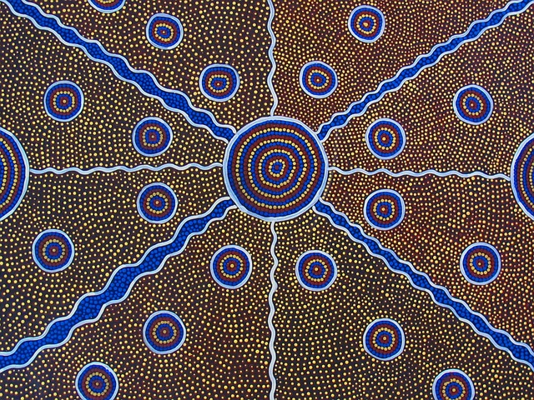
THEATRES
https://www.sydneyoperahouse.com/
https://www.sydneytheatre.com.au/
https://www.ensemble.com.au/
https://www.seymourcentre.com/
https://capitoltheatre.com.au/
https://www.sydneylyric.com.au/
https://www.statetheatre.com.au/
https://www.theatreroyalsydney.com/
https://www.roslynpackertheatre.com.au/
https://belvoir.com.au/
FERRY INFO --Trips from Circular Quay to Manly or Watsons Bay are an easy and cheap option to see Sydney Harbour
https://transportnsw.info/routes/ferry

MUSEUMS and ART GALLERY
https://www.sea.museum/en/home
https://australian.museum/
https://www.artgallery.nsw.gov.au/

ZOO and AQUARIUM
https://taronga.org.au/sydney-zoo
https://www.visitsealife.com/sydney

OTHER ACTIVITIES and WALKS
https://www.sydney.com/destinations/sydney/sydney-city/city-centre/attractions/sydney-tower-eye
https://www.bridgeclimb.com/
https://www.whalewatchingsydney.com.au/
https://hellobondi.com.au/walks/bondi-to-bronte-coastal-walk/
https://www.nationalparks.nsw.gov.au/visit-a-park/parks/malabar-headland-national-park
https://www.sydney.com/things-to-do/tours/sydney-fish-market-behind-the-scenes-tours

